**1.Introduction**

1.1 Overview:

Cardiovascular diseases (CVDs) are the important cause of death. Heart failure is a impact of CVD and this dataset contains 9 features that can be used to predict mortality by heart failure. For this problem, machine leraning algorithms are used.In this project, heart failure prediction is done with IBM services like waston studio, machine learning service , cloud object storage and node red application

1.2 Purpose:

The aim of this project to predict heart failure based on given parameters.

**2.Literature review**

**2.1** **Existing problem**

**In existing , Machine learning algorithms has to bulit from scartch with lengthy with python or R programming.**

**2.2**  **Proposed solution  
In proposed solution, with IBM services no /less code we can built the model.**

In recent years, machine learning are used to solve real time projects. In machine learning, classification ,regression problems are solved with chosen metrics and hyperparameters with training data and test data. Many pipeleines are created with different parameters.

**Theoretical analysis:**

**Overall Diagram for prediction using auto ai .**

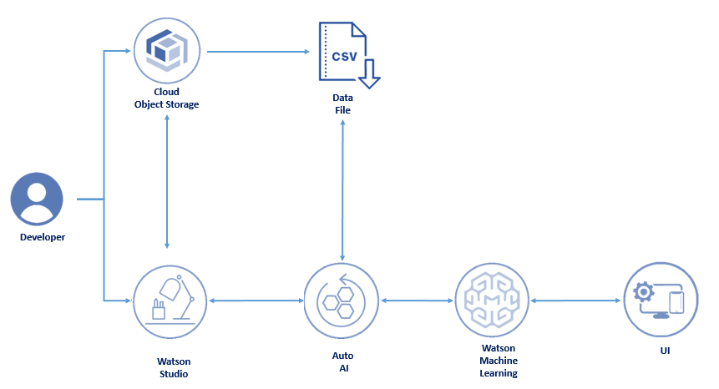

Software designing

1. First create a login in IBM cloud using institutional email id.
2. From catalog , choose watson studio. watson studio service created region must be noted.
3. Click the get started icon in watson studio.
4. From there, click to new projects.
5. Give project name and add cloud object storage for running the project
6. Once cloud object storage is created, from add to project choose auto ai .
7. Then, add machine learning service to the project.
8. The machine learning services created in region similar to watson sudio service region. For example if watson studio is created dallas region then machine learning service ia also to be created in dallas region.
9. Associate the machine learning service to project.
10. Add the dataset for given problem.
11. Fix the prediction column.
12. Run the experiment.
13. Once the run has completed, choose the first rank model for deployment
14. In deployment, create a space for deplyoment.
15. Then in deployment , choose online deployment type with COS and machine learning service for deployment.
16. Once deployed, test the model with some values.
17. Copy the endpoint of deployment.
18. Node red app has been created under cloud foundary app.
19. By clicking to node red app , click to visit app url
20. then node red flow has been shown
21. For this heart rate prediction, import json file and create the node red flow.
22. Using IAM, create API Key and provide input to node red
23. Then endpoint must be provided in node red (http request) for application building
24. once flow has created, deploy the app.
25. In webpage, give sample values for test then complete the project.

**Application building:**

Node red flow

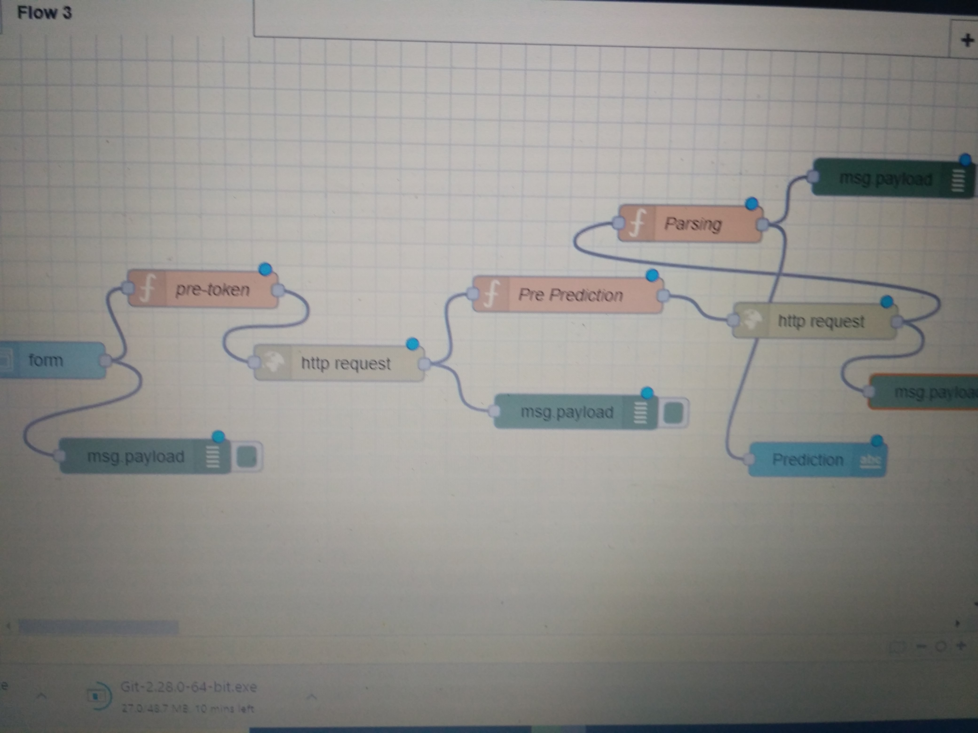

**Result**

Output of Heart rate failure prediciton

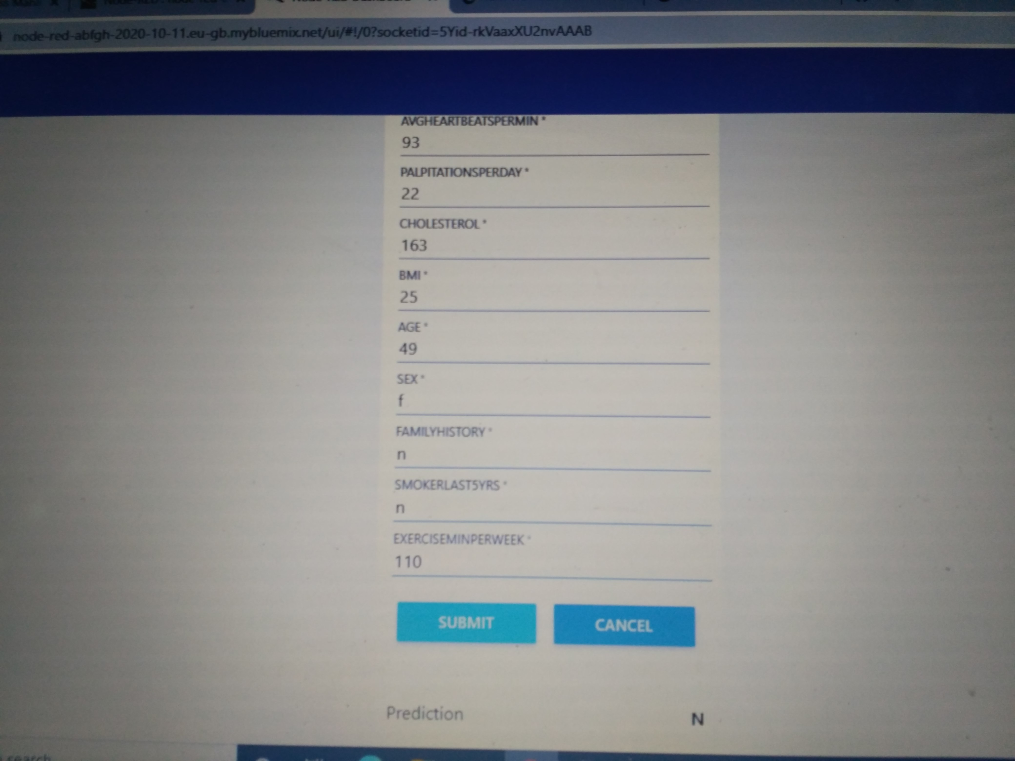

**Conclusion**:

In this, we have GBM classifier is concluded with best model among other existing machine learning models.

**Future scope:**

In future, many classification algorithms with different hyperparameters can be used to solve the problem.